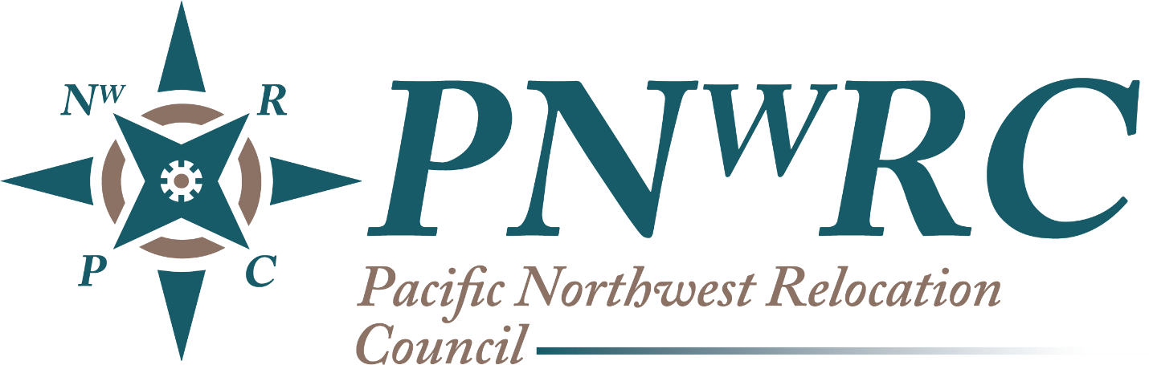

2020 Scholarship Application Packet
Introduction

The Pacific Northwest Relocation Council, a non-profit organization consisting of a community of relocation and HR professionals committed to education, collaboration and the exchange of ideas. With firm roots in the Pacific Northwest, the PNwRC is a diverse organization representing corporate, non-profit and service provider members, who all have a common interest in global mobility. 2020 is an important year, as this is the start of our scholarship program.
The one-time award of $2,500 will be presented to one Western Washington high school senior, graduation in 2020. The award will be sent to the college that the student will be attending to assist with tuition, etc.
The PNwRC will select the scholarship winner based on the strength of their total package. The applicants will be evaluated on academic performance, extra-curricular activities, and on their response to a personal essay addressing their relocation to a new area and high school.

Please complete the packet and be mindful of the March 1, 2020 deadline.

2020 Scholarship Application
The Pacific Northwest Relocation Council is offering one scholarship for $2,500 for 2020 Western Washington high school seniors that were relocated between the 9th and 12th grade.
We are accepting applications between October 1st, 2019 and March 1st, 2020.
Please follow the directions perfectly, applicants will be immediately disqualified if there are any errors or missed information.

APPLICANT CRITERIA
Currently a Senior in good standing in a Western Washington area high school (documentation required)
Relocated no less than 50 miles and changed high schools between the 9th and 12th grade
Has a GPA of 2.5 or better on a scale of 4.0 (documentation required)
Provides SAT/ACT scores (documentation required)
Provides a list of extracurricular activities and work/community work experiences
Submits an essay of 1,000 + words, in word format that, at a minimum, addresses the Student Applicant’s challenges and experiences encountered while relocating to their new home and high school, as well as any successes achieved. It is highly recommended that the essay contain advice the Student Applicant would give to another teenager preparing to relocate. Please compose a thoughtful and personal 1,000+ word essay. Please ensure the font is Calibri, size 12.
Please submit your application following the links and pressing the submit buttons when prompted.
The winner will be notified by April 1st, 2020. The Scholarship will be presented to the winner at our 2020 Spring meeting in April. The winner will be sharing their essay to the membership and photos will be taken to share on our website and social media outlets.
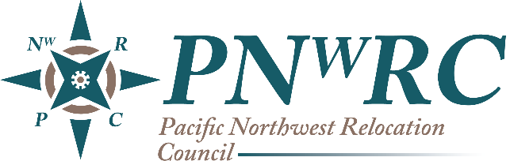
2020 Scholarship Application
Today’s Date: Click or tap to enter a date.
Student Name: Click or tap here to enter text.
Home Address: Click or tap here to enter text.
Email Address: Click or tap here to enter text.
Cell Phone: Click or tap here to enter text.
High School Name: Click or tap here to enter text.
High School Address: Click or tap here to enter text.
Month/Year moved to the Seattle Area: Click or tap here to enter text.
Relocated to Western Washington from (City/State): Click or tap here to enter text.
Please describe any work / community work experiences you have had during high school (please include year and city/location): Click or tap here to enter text.

By signing this, I certify that the information I am providing in this application is my own work and that the information I have provided is true and to the best of my knowledge.

Signature (Please erase this note and insert Microsoft Office Signature line, and sign)

2020 Scholarship Application
Required Documentation

To be completed by High School Guidance Department or High School Official.
Please upload a copy of transcripts/test scores with the application.
Date: Click or tap to enter a date.
Grade Point Average: Click or tap here to enter text.
Grade Point Average Scale: Click or tap here to enter text.
Most recent Test Scores: ☐SAT Score: Click or tap here to enter text.
☐ ACT Score: Click or tap here to enter text.

School extracurricular activities: Click or tap here to enter text.

Information provided by:
Name: Click or tap here to enter text. Title: _______________________

Signature:

Phone: Click or tap here to enter text. Email Address: Click or tap here to enter text.

2020 Scholarship Release Form
INDIVIDUAL CONSENT AGREEMENT LINK (student must be 18 years old today, otherwise, please have parent fill out the release using the Parent Link)

I, Click or tap here to enter text., the undersigned, hereby authorize the Pacific Northwest Relocation Council (PNwRC) and its representatives, successors, and assigned, to use my name, photo, and written essay (or portions thereof) about my relocation (that accompanied my PNwRC 2019 scholarship application) for publication in print, website or social media. I represent and warrant that the attached statement represents my true opinion. I further represent that I am eighteen years of age and have every right to grant these rights.

If under eighteen years of age, please have a parent read through and sign below where indicated.

Signature (Please erase this note and insert Microsoft Office Signature line, and sign)
Date: Click or tap to enter a date.

I represent that I am a parent/legal guardian of Click or tap here to enter text.. As their parent/legal guardian, I have the legal authority to grant the right set forth above.

Signature (Please erase this note and insert Microsoft Office Signature line, and sign)
Date: Click or tap to enter a date.

2020 Scholarship Essay Submission
Name: Click or tap here to enter text.

.

